How to Poop in the Woods

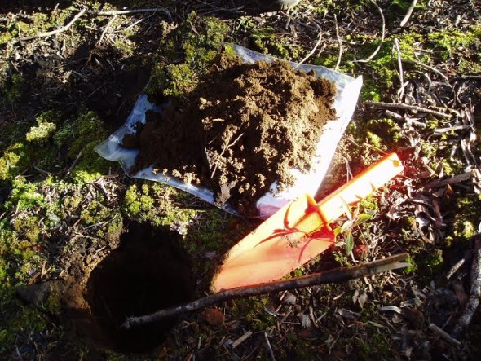

Everybody poops, and everybody who enjoys the backcountry has probably heard talk about how to poop in the woods. There are many good reasons why this is such a popular topic – pooping without a toilet is something most people in the developed world find uncomfortable at best, and when done incorrectly, it can leave unpleasant and toxic piles near campsites or trails.
Nobody wants to see a human poo sitting on the side of the trail, nor would they want invisible poo particles leeching into a pristine stream where they may need to get their drinking water. With that in mind, the proper etiquette for Leave No Trace (“LNT”) pooping is one of the most important things you can learn before hitting the trail.

(See SM’s Tips at the end of this Article for Troop Practices & Protocols)
Option 1: The Outhouse
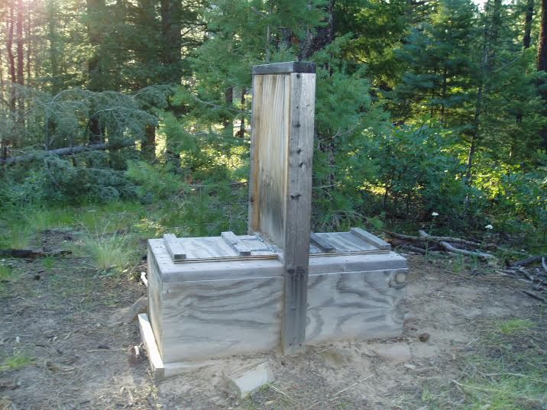
The easiest way to take a LNT dump is to do it in a toilet. Whether it's a vault toilet at a trailhead, or an outhouse at a campsite, the toilet in question was designed to consolidate human waste in a place that is easy to use.
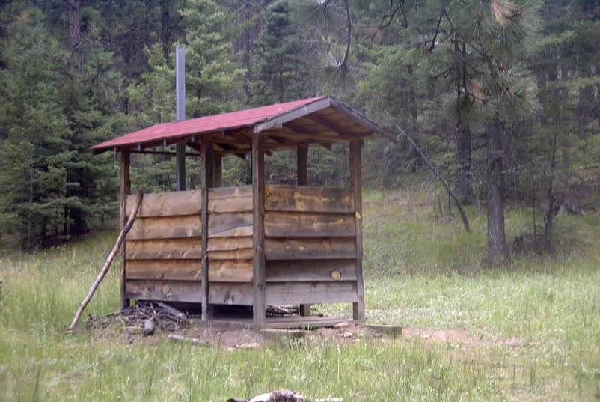
Different types of outhouses are available at different campsites and trailheads, but they're almost always situated where lots of people may need to go, so there will be a high volume of poop. If there's a toilet at your campsite, use it instead of going on to option 2, the Cathole.
Option 2: The Cathole
A cathole is the most widely accepted method of backcountry human waste disposal outside of a toilet -- dig a hole, poop in it, cover it. The advantages are:

1. They are easy to dig in most areas.
2. They are easy to disguise after use.
3. They are private.
4. They disperse the waste rather than concentrate it (enhances decomposition)
5. It is usually easy to select an out-of-the-way location where you can be certain no one is going to casually encounter the cathole.

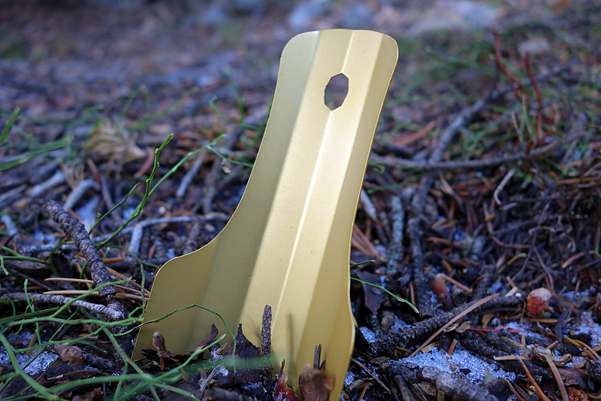
A problem with catholes is that animals will often dig them up to get at partially digested buried food particles in feces. This tends to mix soil with feces (a good thing), but changes animal behavior (a bad thing), and possibly worst of all can leave dug-up toilet paper “flowers” (“Jersey Lilies”) in the area (another bad thing). One solution is to pack out toilet paper (TP) or use leaves or other natural materials as TP, but animals will still be attracted to the cathole as a food source. Another solution is to make Poop Soup. A further benefit of the “Poop Soup” technique is the funny name and the humor that can be put into teaching youth and adults an effective cathole technique.
Selecting a Cathole Site:
1. Select a cathole site far from water sources, trail, or camping sites. 200 feet (approximately 70 adult paces) is the recommended range.
2. Select an inconspicuous site untraveled by people. Examples of cathole sites include thick undergrowth, near downed timber, or on gentle hillsides.
3. If camping with a group or if camping in the same place for more than one night, disperse the catholes over a wide area; don’t go to the same place twice.
4. Try to find a site with deep organic soil. This contains organisms which will help decompose the feces. (Organic soil is usually dark and rich in color.) The desert does not have as much organic soil as a forested area. (See number 2 below.)
5. If possible, locate your cathole where it will receive maximum sunlight. The heat from the sun will aid decomposition.
6. Choose an elevated site where water would not normally collect during runoff or rain storms. The idea here is to keep the feces out of water. Over time, the decomposing feces will percolate into the soil before reaching water sources.

Digging a Cathole:
1. A small trowel is the perfect tool for digging a cathole. If you don’t have a trowel, you can use a stick, a flat rock, a hiking pole, or a tent peg as a digging implement, but it will probably take you longer. A trowel will be more efficient and ensure you make a proper cathole. They are inexpensive and some are extremely light.
2. Dig the hole 6-8 inches deep and 4-6 inches in diameter. In a hot desert, human waste does not biodegrade easily because there is little organic soil to help break it down. In the desert, the cathole should be only 4-6 inches deep. This will allow the heat and sun to hasten the decay process.

Making Poop Soup:
After depositing waste into the cathole,
1. use a sturdy stick (not your trowel) to mix all of this with some loose soil,
2. then add a cup or so of water* and mix again. The soil and feces should not be recognizable as such once thoroughly mixed in this soup. The thorough mixing of all of the cathole contents with soil and water will speed decomposition and make animal digging less likely. Packing out toilet paper will completely avoid the “TP flower” problem.
* there is some disagreement as to how essential it really is to add water to the mix, but if you can spare some, it does speed the mixing process

Topping Off the Cathole:
When finished, the cathole should be topped off with the rest of the original dirt and disguised with native materials.

Option 3: Carry In, Carry Out
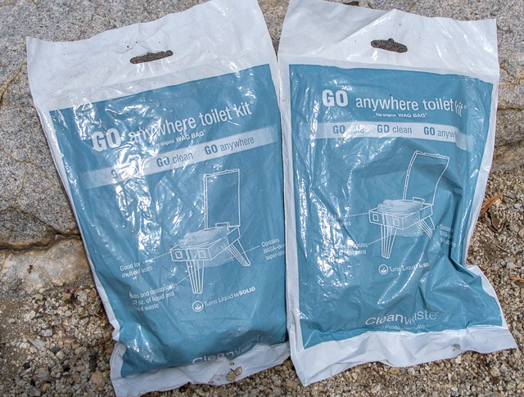
In places where outhouses are not available and decomposition is unlikely to happen quickly, you may be required to pack it out, just like any other trash. Narrow river canyons, popular high elevation destinations (like Mount Whitney), or glaciers are examples of places where your poop won't decompose, so you'll want to pack a few WAG Bags. A “WAG” Bag stands for Waste Agglutination Gel - Poop in the bag, seal it, and pack it out with the rest of your trash. Otherwise your poo will be left sitting there for decades to come.
Note: Be sure to learn, and use, and site specific methods and practices:
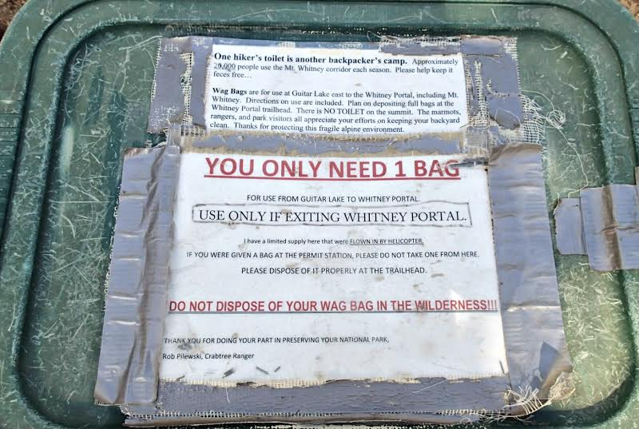
TP-less Options
For an even more trace-less dump, you can go the route of using natural materials instead of toilet paper. There are countless materials you can find in the woods and mountains that work just as well as TP, with the added benefit that you aren't introducing a new material to the environment, and you won't have to worry about
running out. The only downside is that they may take some getting used to, since we're all mostly comfortable with paper.
Snow and water are the cleanest and most gentle solutions. For snow, you'll want rounded, packed snowballs with a bit of a cone shape. The best snowballs wipe and wash at the same time, while also giving you a little wake-up jolt at first. Water on its own isn't much use, but you can make a makeshift bidet with either a squirt bottle or a hand (always wash with soap after going!) that is surprisingly effective.
Broad leaves and moss may be the most comfortable natural option for those of us used to paper, but you'll want to be careful about picking live plants. That's generally frowned upon, especially if lots of people start doing it. The forest can very quickly be picked clean.
Another abundant option is smoothed stones from stream beds or smooth sticks. Just don't get too aggressive with your wiping, since neither is quite as forgiving as soft TP.
What about urine?
The nice thing about human urine is that it is sterile and does not have any illness-causing bacteria that can get into streams and lakes. The not so nice things about it include an unpleasant odor from ammonia and other concentrated liquid wastes, and concentrated salts, which are sought after by some animals, especially deer, sheep, and goats. We have even had the experience of being followed around at a distance by mountain goats, just waiting for us to pee so they could get the salt. When you pee on vegetation or on soil at the base of living plants, these salt lovers will tend to come by later and can be fairly destructive of soils and plants.
To avoid this, especially in alpine areas or other places with fragile vegetation, try to pee on rocks or other durable surfaces that will not be damaged by salt-seeking animal activity. Remember as well to pee off trail and away from camping areas so that the odor will not assault the nose of the next hikers to come along.

This article was contributed by Gossamer Gear Trail Ambassadors and Leave No Trace Master Educators Ryan "Guthook" Linn and Rob "QiWiz" Kelly.
Editor | April 6, 2015 at 8:00 am | Tags: dig a cathole, leave no trace, poop in the woods, toilet paper alternatives | Categories: Tips and Tricks | URL: http://wp.me/p3LDw5-3Ge

Scoutmaster’s Tips on Troop Protocols & Practices
- Plan & prep your KYBO Kit in advance and pack so it is easily accessible and completely self-contained/sealed in a freezer quality zip lock bag:
  - Back Packer’s Cat Hole Shovel (at least one between/among hiking buddies)
  - Length of TP or Napkins (recycled & not dyed are best)
  - Sani Wipes - Individually Wrapped (NOT with isopropyl alcohol!!!)
  - Desitin – in half of contact lens cleaning kit is also nice to have to treat “monkey butt”. Cut the lens kit in half & fill with diaper rash cream/Desitin

- Buddy System – while this is certainly a private practice, the buddy system is still followed:
  - Place your pack on the side, and in plain sight, of the trail on the side you ventured off to dig your cat hole.
  - Your hiking buddies should, preferably, wait on the trail for you to return or, at least, until the next Troop buddy group shows up to whom they can pass the buddy baton. The “sweep” group or adult should NEVER hike past.
  - If you come upon a Troop member’s pack on the side of the trail and no hiking buddy is present, do NOT walk past.

- NEVER use the shovel for ANYTHING but digging the hole:
  - It should touch nothing but virgin dirt, not even to fill hole back in
  - Use clean stick & leaf to clean dirt off of shovel
  - Find sticks (I find two, a larger and smaller diameter, work best) to push feces to bottom of hole and grind up & mix TP with feces (Poop Soup)
  - When done, toss the sticks away from the cathole so that scent is not an open maker for critters that may dig up your cathole.

- Minimize TP & Trash:
  - 1st wipe can be with a leaf
  - 2nd wipe can be with TP/Napkin
  - 3rd wipe can be with sani wipe (put sani wipe wrapper back in KYBO Kit bag)

- Hygiene is as important to you as LNT is to the environment:
  - Use a 2nd sani wipe – or – soap and water to wash your hands (either stage at your pack before you head off or, better, have your buddy handle water bottle & soap so that you are not doing so).
  - Hand sanitizer is a good follow up, but not substitute for, this 1st step.
  - Make sure you do this BEFORE handling your gear, touching face, etc.
  - This applies to using an outhouse as well!
  - Repeat 4 & 5 if you start developing “monkey butt” down the trail
  - Repeat 5 if you are later preparing meals, handling food, cooking gear, water bottles, filters, etc.
In the words of John Cleese “And now for something completely different, …”

At the risk of not being PC, something I have just never been willing or able to grasp or practice, see the following contemporary literature and popular culture sources on the importance of poop and pooing in the woods:

Bill Bryson, A Walk in the Woods, musing about why he decided to hike the AT:
“I formed a number or rationalizations. It would get me fit after years of waddlesome sloth. It would be an interesting and reflective way to reacquaint myself with the scale and beauty of my native land after nearly twenty years of living abroad. It would be useful (I wasn’t quite sure in what way, but I was sure nonetheless) to learn to fend for myself in the wilderness. When guys in comouflage pants and hunting hats sat around in the Four Acres Diner talking about fearsome things done out-of-doors, I would no longer have to feel like such a cupcake. I wanted a little of that swagger that comes with being able to gaze at a far horizon through eyes of chipped granite and say with a slow, manly sniff, “Yeah, I’ve shit in the woods.”

Bill Bryson, A Walk in the Woods, later musing about how hiking the AT had transformed him:
“We were real hikers now. We had shit in the woods and slept with bears. We had become, we would forever be, mountain men.”

Scrubs: “Everything Comes Down to Poo”
https://www.youtube.com/watch?v=uRvk-CnXYhI

